Smoked Pork Rib Tacos with Honey Lime Slaw

**Ingredients:**

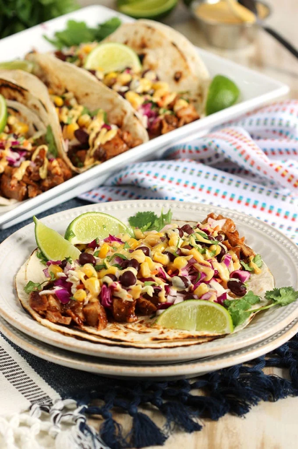

* 1 rack Smoked Pork Ribs
* 1 cup shredded green cabbage
* 1 cup shredded red cabbage
* 1/2 cup shredded carrot
* 1/4 cup fresh chopped cilantro
* 1/4 cup fresh lime juice
* 3 tablespoons apple cider vinegar
* 3 tablespoons honey
* 1/2 teaspoon kosher salt
* 1/2 teaspoon fresh ground pepper
* 3/4 cup Signature Kitchens Mayonnaise
* 1/2 cup Signature Kitchens Southwestern Style Mustard
* 1 cup Signature Kitchens Black Beans, drained and rinsed
* 1 cup cooked corn kernels
* 1/4 cup finely diced red onion
* 8 Signature Kitchens Flour Tortillas
* Fresh cilantro, for garnish
* Lime wedges, for garnish

**Instructions:**

1. Reheat the Smoked Pork Rib. Allow to cool enough to handle.
2. Using a sharp knife, carefully cut the meat from the rib bones and roughly chop into bite sized pieces. Set aside.
3. In a medium bowl, toss together the green cabbage, red cabbage and cilantro to combine.
4. In a small bowl, whisk together the lime juice, vinegar, honey, salt and pepper. Pour the dressing over the cabbage and toss to combine. Set aside.
5. In a separate bowl, whisk together the mayonnaise and mustard until smooth. Set aside.
6. In a medium bowl, stir together the black beans, corn and red onion. Set aside.
7. Carefully char a tortilla over a grill or gas burner until lightly toasted. Repeat with remaining tortillas until done.
8. Divide the pork evenly between each tortilla. Top each with 2 tablespoons slaw, 2 tablespoons black bean relish and drizzle with the mustard.
9. Serve immediately sprinkled with additional chopped fresh cilantro and lime wedges, if desired.