Grilled Brisket Nachos
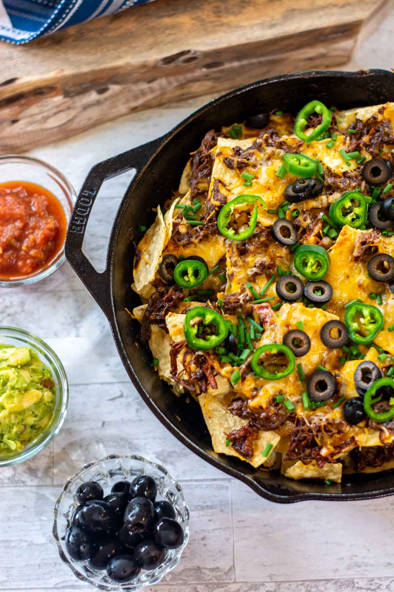
Ingredients:

- 2 cups Smoked Brisket shredded
- 1/2 cup Onion diced
- 1/2 cup Beer
- 1/2 tsp Cumin
- 1 clove Garlic minced
- 1 tbsp Chili Powder
- 1/4 tsp Dried Oregano
- 1 tsp Olive Oil
- 8 oz Mexican Cheese shredded
- bag Tortilla Chips larger ones work best

Instructions:

- In a cast iron skillet, add olive oil and heat 3-5 minutes

- Add chopped onions and cook for about 5 minutes until they become soft and start to brown

- Add in shredded brisket, seasonings, garlic and beer. Stir until well combined.

- Take brisket mixture out of cast iron skillet and add to a bowl. Add about 1/3 of the cheese to this bowl and combine until it melts in with the rest of the mixture.

- Heat oven to 400 degrees

- Spray the bottom of the cast iron skillet. Layer chips on bottom of skillet. Add half of the brisket to the chips, sprinkle with half of the remaining cheese.

- Layer on another layer of chips, add the remaining brisket mixture and top with cheese.

- Cook at 400 for about 10-12 minutes, or under cheese fully melted

- Top with your favorite toppings and serve immediately

Notes
Toppings: Add on toppings of your choice on top. In the photo, we added olives, chives and jalapeño pepper slices.

