Pork Rib Soup
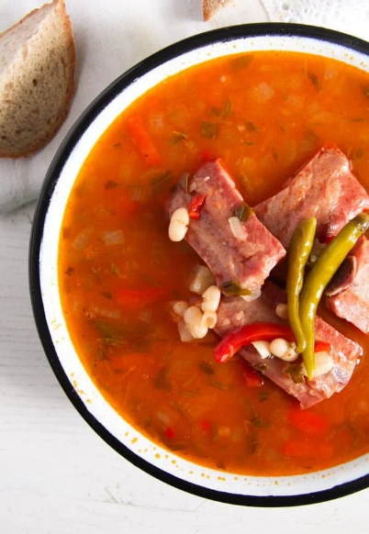
Ingredients:

- 8.8 oz/ 1 ¼ cups dried white beans
- 1lbs smoked pork ribs
- 3.5 oz celeriac
- large carrots
- 1 large onion
- 1 red bell pepper
- tablespoons vegetable oil
- 2 tablespoons all-purpose flour
- 2 tablespoons tomato paste
- pickled tarragon and 1-2 tablespoons of its pickling vinegar or fresh tarragon + 2-3 tablespoons vinegar to taste OR if not using tarragon
- fresh lovage/celery leaves and fresh parsley + 2-3 tablespoons vinegar to taste
- fine sea salt and pepper

Instructions:

- Rinse the dry white beans, place them in a large bowl, and cover them with water. Leave to soak overnight.
- Drain the beans and place them into a pot together with the smoked ribs, which you have cut into smaller pieces. Cover with water, about 2 ½ liter/ 10 ½ cups and bring to a boil. Turn the heat down and simmer for about one hour or until the beans are almost done. Prolong the cooking time if the beans are not almost soft, it really depends on the size and age of the beans.
- In the meantime, chop all the vegetables. Add them to the pot and continue cooking for another half an hour or until the beans and the veggies are soft. Add the vegetable stock powder or cubes and stir well.
- Heat the oil in a small pot. Add the flour and stir well for one minute. Add the tomato paste and stir well.
- Take a soup ladle full of hot soup from the pot, trying to avoid the beans and vegetables, and slowly pour it over the flour mixture while whisking all the time. When the liquid is incorporated and the mixture has no clumps, add another one or two soup ladles, while whisking all the time.
- When the mixture is pourable, slowly pour it into the soup while whisking all the time to avoid clumps. Simmer the soup for another 5 minutes.
- In the meantime chop the herbs you are intending to use.
- If using fresh lovage/celery leaves and parsley, chop and add them to the soup when you are done cooking. Add 2 or 3 tablespoons vinegar to sour the soup to taste and add salt and pepper.
- If you are using pickled tarragon, chop it finely and add it to the soup together with 2 or 3 tablespoons of the pickling vinegar, to taste. Adjust the taste with salt and pepper.
- Serve with bread and raw red onions.

