Guinness Brisket Baked Beans in a Slow Cooker

**Ingredients:**

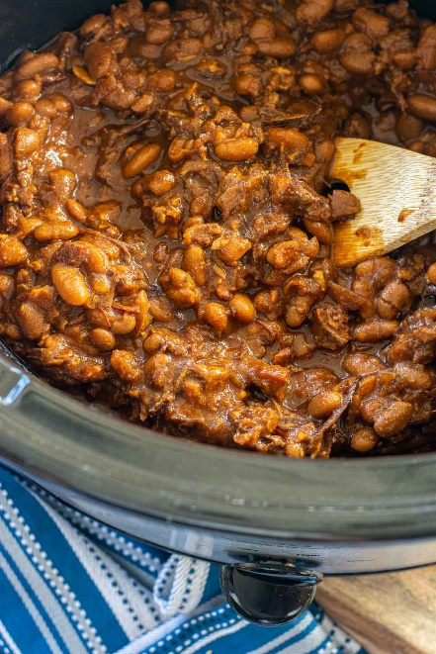

* 2 cups Brisket cooked, smoked, shredded
* 8 oz Bacon cooked and chopped
* 4 cans Great Northern Beans drained and rinsed
* 12 oz Guinness Beer
* 1/3 cup Tomato Paste
* 1 cup Molasses
* 2 tbsp Ketchup
* 1/3 cup Yellow Mustard
* 1 cup Shallot chopped
* 2 cloves Garlic minced
* 1/4 cup Brown Sugar dark
* 1/4 cup Honey
* 4 oz Water

**Instructions:**

1. Spray or line the Slow Cooker and add all ingredients. Shred or cube the cooked brisket.
2. Cook on low for eight hours. Check at the six hour mark and if it isn't getting dark and thick, turn up to high the last two hours.
3. Serve over rice or with corn chips