One Pot Leftover Sausage Pasta

**INGREDIENTS:**

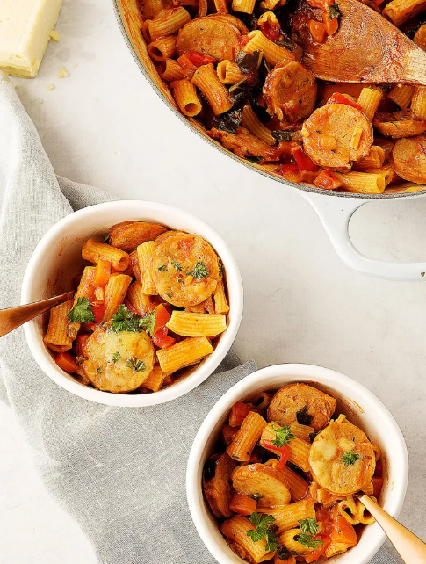

* 1 tablespoon extra virgin olive oil
* 1/2 white onion, finely diced
* 1 red capsicum, finely diced
* 1 carrot, finely diced
* 2 cloves garlic, finely diced
* 2 tablespoons tomato paste
* 2 tomatoes, diced
* 2 cups spinach, chopped
* 1 teaspoon dried basil
* 1/2 teaspoon fennel seeds
* 2–4 leftover cooked sausages, sliced
* 3 cups chicken stock
* 300g dried pasta, uncooked
* 1 cup grated cheese, Mozzarella or Cheddar is fine
* fresh basil or parsley to serve

**INSTRUCTIONS:**

1. In a large frypan, over medium heat, add the oil, onion, capsicum, carrot, garlic and cook 5 minutes, until they start to soften. Add the tomato paste and mix through. Add the tomatoes, spinach, basil, fennel seeds and sausage.
2. Pour in the broth then mix through the dried pasta until really well combined. Place on lid and cook 8 minutes, stirring regularly to make sure it isn’t sticking on the bottom and the pasta is being well coated with liquid. Remove lid and stir through cheese.
3. Serve topped with fresh basil or parsley.