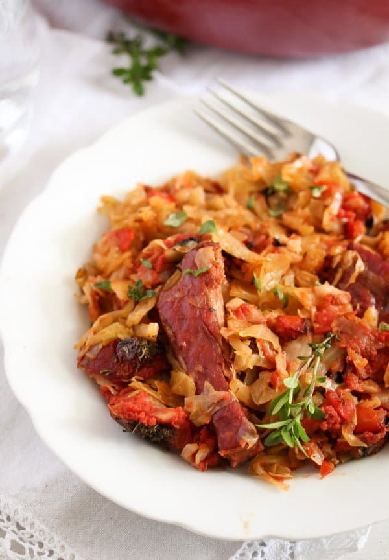
Ribs and Cabbage

Ingredients:

- 2 lbs white or green cabbage 1 kg
- ½ teaspoon fine sea salt
- 1 medium onion
- 1 red bell pepper
- 2 tablespoons vegetable oil
- 2-3 bay leaves
- 12.5 oz smoked pork ribs
- 1 ½ cups passata di Pomodoro/ tomato puree/ strained tomatoes 350 ml, Note 2
- ½ cup hot water 125 ml
- 5 medium tomatoes
- 1 tablespoon dried summer savory or dried thyme
- 1 teaspoon granulated sugar
- fine salt and pepper to taste
- sour cream/smetana/Greek yogurt white bread or boiled potatoes to serve

Instructions:

- Slice the white cabbage very finely; you can use a mandoline if you like. Mix the cabbage very well with the salt and let stand for half an hour, it will soften.

- In the meantime, chop the onion finely and cut the red bell pepper into small thin slices. Prepare the smoked pork spare ribs by cutting them apart into single pieces, cutting in between the bones with a large sharp knife.

- Preheat the oven to 350°F/ 180°C.

- Cook vegetables: Heat the oil in a wide Dutch oven or another heavy-bottomed, oven-safe pan with a lid. Saute the onion and the pepper for about 2-3 minutes. Add the cabbage and bay leaves and saute, stirring often, for 10-15 minutes or until a little softer. Add some salt and pepper to taste.

- Assemble pot: Remove half of the cabbage from the pot. Arrange the spare ribs on top of the remaining cabbage and cover them with the cabbage you removed previously.

- Mix the passata, 125 ml/ ¼ cup hot water, finely chopped tomatoes, summer savory, and sugar. Pour this mixture over the cabbage, and move the cabbage a little with the handle of a wooden spoon, making some kind of holes here and there, allowing some of the liquid to leak through the cabbage.

- Bake: Cover the pot and bake the cabbage casserole for 1 ½ to 2 hours until the cabbage is really soft and the meat of the ribs falls off the bones.

- Serve as suggested above, either immediately or reheated, with a dollop of sour cream/smetana/Greek yogurt on top and white bread or boiled potatoes.

