Brisket Grilled Cheese

Ingredients:
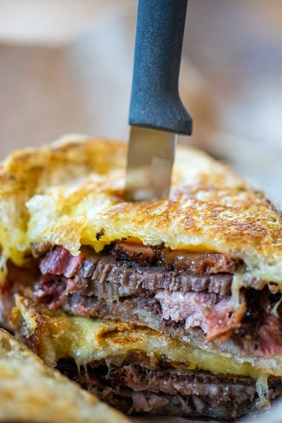
- 4 Sliced Bread
- 4 oz Brisket thin slices to allow about 2 oz per sandwich
- 1 cup Cheese grated as it melts easier
- 4 tbsp Butter

Instructions:

- Cut the brisket into thin slices. You will need 2-3 slices of brisket depending on how thick you want your sandwich. Grate the cheese. We used Fontina and Gruyere.

- Butter the bread.

- Heat the skillet to medium. Don't set the temperature too high as the bread will get too toasty too fast and then the cheese won’t melt. A big reason we shredded the cheese was to help it melt faster. Start with the cheese on the bottom slice of bread to help it melt more quickly and so when you flip it, the shredded cheese doesn’t fly all over the place.

- Butter one slice of bread. Add the shredded cheese and the sliced brisket. Top with another slice of buttered bread.

- Place the sandwich in the skillet and cover it with a lid to help the cheese melt faster. Flip the sandwich once the bottom has become golden brown and toast the second side.

- Remove, cut in half, and serve!

Notes:

Extra Butter: Try to add just a dab of extra butter to the pan before you add the sandwich. This makes the sandwich very rich and gooey…think of those restaurants where you get a really great grilled cheese and you don’t know why. More butter is usually the answer. I never said this was low fat! 😀

Grated Cheese: Grating the cheese will help it melt faster so you don’t have a burnt sandwich and hard cheese.

