Brisket White Queso Nachos
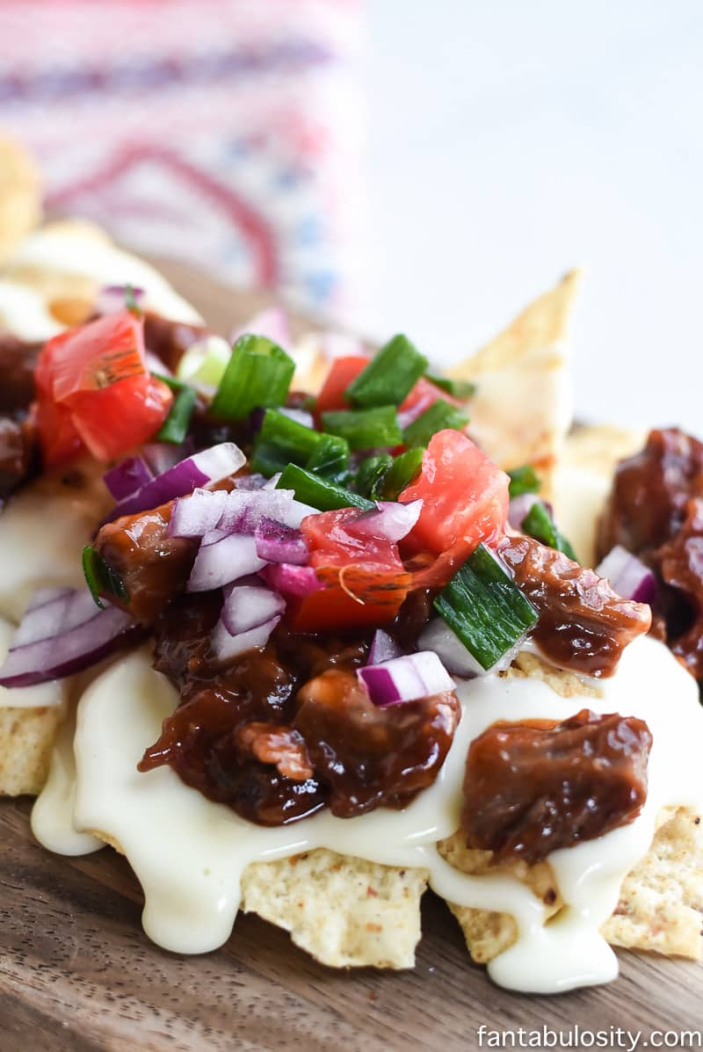
INGREDIENTS:

- 1 block white queso Velveeta
- 2- 3 Tablespoons milk or desired amount for preferred texture
- 1 cup smoked brisket (more is even better)
- 1/2-1 cup BBQ sauce
- green onion chopped
- 1 tomato chopped
- 1/2 red onion chopped

INSTRUCTIONS:

- According to package directions, melt your white queso and milk in the microwave.

- In a separate bowl, generously coat your cooked meat with BBQ (The more the better, in my opinion)

- On a large platter or individual plates, place a layer of tortilla chips.

- Pour melted white queso over the top of the chips.

- Top with additional ingredients that you desire.

