BREAKFAST SKILLET RECIPE WITH BRISKET

**INGREDIENTS:**

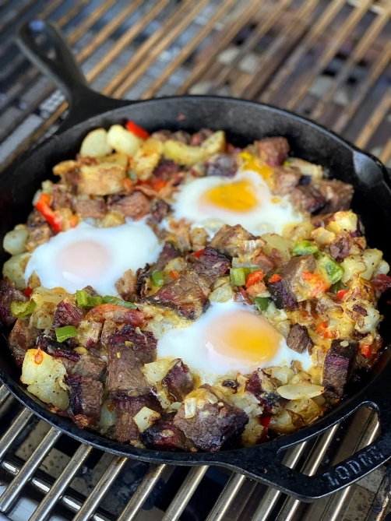

* 2 Cups brisket, cut into 1-inch pieces
* 3 strips bacon, cut into 1-inch pieces
* 3 Cups potatoes, baked and cubed into 1-inch pieces
* 1/2 Cup white onion, diced
* 1 clove garlic, minced
* 1/4 cup of red bell peppers, diced
* 1/4 cup of jalapeno, sliced
* 1 Cup cheddar cheese, shredded
* 1 Tbsp avocado oil
* 1 Tbsp butter
* 1 Tbsp seasoning
* Diced cilantro to taste

**INSTRUCTIONS:**

1. Preheat grill or stove to 350 degrees. In a cast iron skillet warm up avocado oil and butter. Cook onions, red bell peppers, then garlic and jalapeno in same skillet. Cook until sauteed. Scoop ingredients into a bowl for later use, keeping grease in skillet.
2. Place potatoes in skillet, cooking to when they get a little crust. Dump in brisket and bacon pieces. Cook for a few minutes. Bring ingredients from bowl back into the skillet. Sprinkle on seasoning. Mix altogether, creating three divots in the skillet of ingredients.
3. Crack eggs, placing one in each of the three divots. Cover with a lid and cook for about five minutes or until eggs are done to your liking. Sprinkle shredded cheese on top. Remove from grill when cheese is melted. Sprinkle cilantro on top. Serve.